What is Cloud?

The cloud is made up of servers in data centers all over the world. Moving to the cloud can save companies money and add convenience for users.

Explanation :-

10-15 years ago, to deploy any application company used to buy physical servers,ex(HP,IBM). With high end specifications Like 100gb of Ram and 100 Cpu.

Physical servers are very costly.

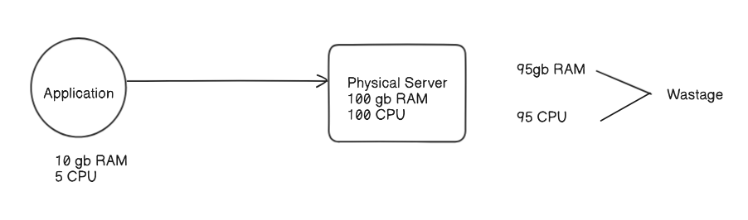

To overcome This wastage of Resource the concept of Virtualisation came into picture . With the help of Virtualization, multiple operating systems and applications can run on the same machine and its same hardware at the same time, increasing the utilization and flexibility of hardware.

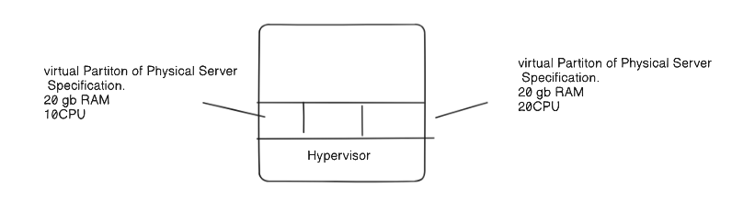

"The cloud" refers to servers that are accessed over the Internet, and the software and databases that run on those servers. Cloud servers are located in data centers all over the world. By using cloud computing, users and companies do not have to manage physical servers themselves or run software applications on their own machines.

